Model Development Phase Template

Date | 20 February 2026
Team ID | LTVIP2026TMIDS66231
Project Title | IntelliSQL: Intelligent SQL Querying Using Gemini Pro
Maximum Marks | 10 Marks

Initial Model Training Code, Model Validation and Evaluation Report
In this project, no custom model training is performed. Instead, a pre-trained generative AI model is integrated and used for natural language to SQL translation. The focus of this phase is on model selection, configuration, prompt design, and output evaluation, rather than training from scratch.

Initial Model Training Code (5 marks):
Model Selection and Initialization
The Gemini Pro (models/gemini-1.5-pro) model is selected for the IntelliSQL project due to its superior natural language understanding capabilities, ability to generate accurate SQL code, and fast response time suitable for real-time applications.
The model is accessed using the Google GenAI SDK, and it is initialized securely using an API key stored in environment variables. The application sends a natural language query along with database schema context to the model, which generates SQL statements.
Since the model is already pre-trained, no training loop, loss function, or optimizer is required.
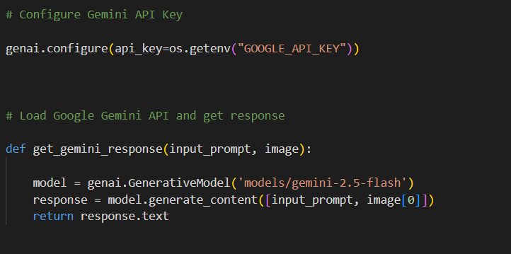

Model Validation and Evaluation Report (5 marks):
Model | Summary | Training and Validation Performance Metrics
Gemini Pro | Pre-trained large language model optimized for natural language understanding and code generation. Capable of translating user questions into accurate SQL queries. | Pre-trained LLM with strong SQL generation capabilities. Evaluated based on query accuracy, response time, and ability to handle various query complexities. No custom training metrics as the model is used as-is.

